*Help restore a poor polluted micro-biome stuck in an arcade claw machine to its former wonder*

*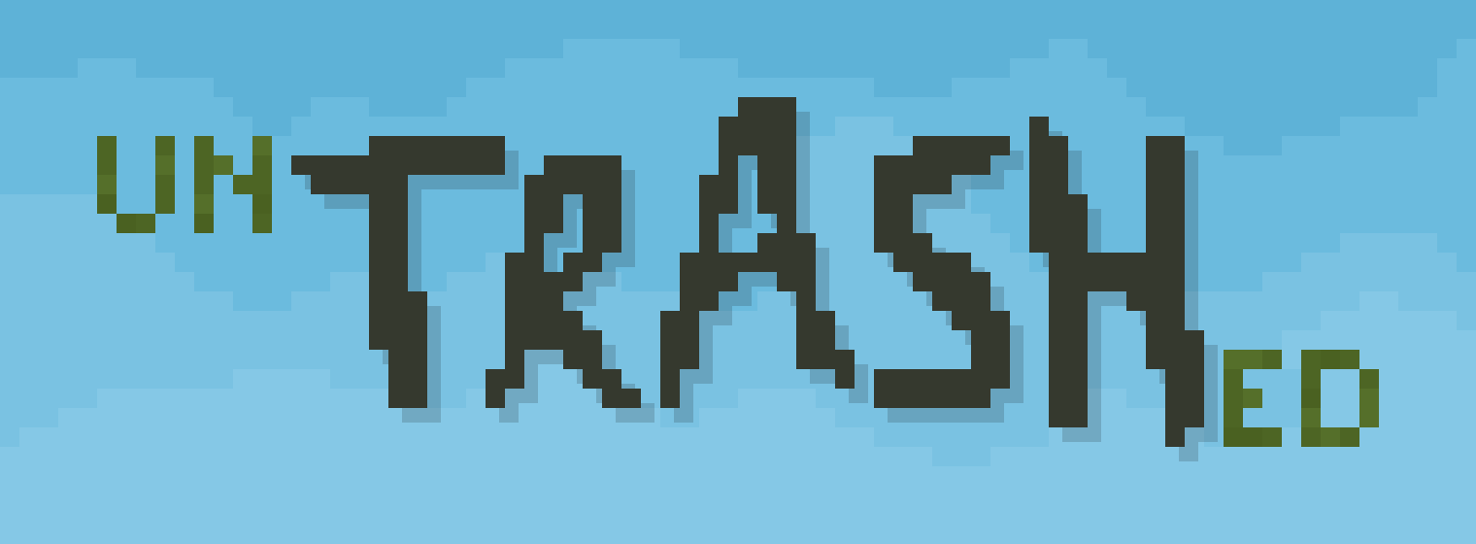Untrashed* is a game I made for the Ubisoft Australia Game Jam 2024. We were given two weeks and were encouraged to team up to make the best game we could around the theme “trash.” However, it took place in the middle of uni semester so I was very busy with assignments so I decided to enter on my own and see how much I could get done in just a few days.

This was the first full project I had completed on my own in a while and was surprised when I came out of it with increased appreciation for working in a team. Sharing workload, skillsets, bouncing ideas, and testing each other’s implementations are just a few of the many benefits of teamwork that I missed throughout the project. That being said, I’m glad I did this one alone since it opened my eyes to these benefits I had taken for granted. I also enjoyed performing roles I would rarely touch otherwise, like art and sound.

From the start, I knew I wanted to focus on:

* Having a unique mechanic. To me, this is what game jams are all about – experimenting with ideas that haven’t been done before and seeing where they take you.
* Getting the game done and polished. I didn’t have a lot of time for this project and over my degree I’ve seen what a monster scope creep could be so I knew keeping a tight rein on the scope and project management was a must.
* Having responsive sound and other interaction feedback elements. This kind of goes hand-in-hand with polish but this was an aspect I really wanted to get right. Having the game respond to a player’s interaction is a huge part of engagement but surprisingly I’ve seen many students and inexperienced developers overlook this aspect.

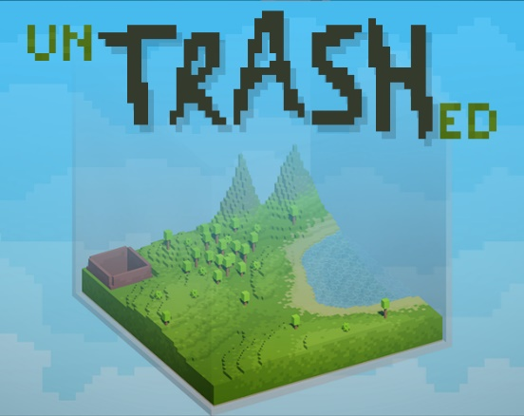With these things in mind I got to brainstorming and ideating. I eventually settled on an idea to get started on and see where it led. A little biome in a claw machine where the player has to use the claw to grab pieces of trash out of the environment. I had lots of ideas to expand this like natural disasters, using the trash in a crafting system, and adding automation elements but I knew I wouldn’t get to them in the allocated time. But I was excited about simple idea without any these massive elements added on so I got started.

Design:

The first thing to figure out was how to implement the claw movement and mechanics. I thought back to my experience with claw machines and watched a few videos and noticed generally the player controls the movement of a “base” which the claw hangs freely from. To replicate this motion I used a cube with a kinematic rigidbody as the base the player controlled then attached a claw with a normal, gravity-affected rigidbody to this with a spring joint. Initially, this motion was way too springy and didn’t feel like a claw game. But after spending a while tweaking anchor points, mass, drag, gravity, rotation constraints, spring values and spring damper values I got the motion about what I was going for. It still felt a little bouncier than real claw games but this extra bounce, swing and energy made the game feel a little more lively so I decided I was happy with this and to keep it this way. This did mean the player would sometimes need to wait for the claw to stop swinging to see exactly were it settled so I increased the drag which fixed it. Along with this, I grey-boxed a level (which was literally just a hollow cube with the front walls missing so the player could see into it) and made the claw using Unity’s Probuilder tool.

The next system to design was actually using the claw to pickup trash. At first glance, this doesn’t seem like a very big deal – just add some colliders to the trash, add some colliders to the claw, let the fingers of the claw close, and let the Unity physics system do the rest. This is what I first played around with. But there turned out to be many issues with this method. The claw’s fingers would struggle to get beneath an object in order to pick it up and when it did, it would often clip colliders through each other, sending the trash flying away. I fiddled around with solutions to this and eventually settled on a system with two parts. 1 – I gave the trash objects two colliders. One that was slightly larger and could interact with everything except the claw and another that was slightly smaller that could only interact with the claw. 2 – I gave each of the claw’s fingers two collider. One that was always active at the “root” of the finger that collided with everything (except the trash’s world collider) and one that only activated when the claw started closing that only interacted with the trash. This system let the claw easily pick small object off the ground with only minimal visual clipping.

This led me into my next problem. The claw often dropped things on its way to deposit them in the “prize chute.” Initially, this is exactly what I was going for since that’s exactly what claw games do. But I found this really frustrating so I tried increasing the size of the colliders so the claw wouldn’t drop objects and it felt much better like this.

I didn’t realise it at the time, but I ran into this same design problem in a few different forms across my design. My initial goal was to replicate a claw machine in a fun scenario but real claw machines aren’t really fun, or at least not fun in the way a player can actually gain skill and progress with them. Real claw games are designed to get money off people and give them the anticipation of *almost* winning something while seldom actually giving away a prize. Each time I ran across this disconnect, I went in favour or what felt fair and fun. I gave my claw more bounce, swing and “weight” while also making it quickly settle in its position so players didn’t need to wait for it. The claw won’t drop things on its way to the prize chute. If the player accidently misses and doesn’t pick up anything, the claw will speed up to give control back to the player quicker. I added camera angles so the player could look directly front and side on to see if they were aligned properly but I made it even easier to see this by adding a spotlight that points directly down from the claw. Every choice I made was to minimise the frustration and annoyance that can be found in real claw machines.

Programming

I didn’t want to do a whole lot of coding for this project. I knew design would take up a lot of my time, I wanted to the game to look, feel and sound good, and I had been programming games since before my degree started. I decided to take a small break from “intense” programming so I focus on keeping my design away from anything that would require me to script complex systems and just use Unity’s existing functionality wherever I could.

I relied on Unity’s physics system for majority of the claw motion and all collisions including picking up objects with the claw. Most of the programming ended up being for input, UI, sound, timers, and small, self-enclosed systems like spawning trash and keeping score.

The most challenging programming problem I ran into was getting the fingers on the claw to open and close well. I’ve never been good at scripting rotations in Unity. There’s just so many methods that do slightly different things that return values that are never what I expect and I can’t visualise how to do it in the editor window by changing the rotation values in the transform component (like I can with the position and scale) because Unity internally handles rotation completely differently from how it shows them in the editor. I ran into a similar issue with Rural Regen, a much bigger game I made in a team a year prior. Nevertheless, using Unity’s Transform.RotateAround method and a bunch of experimentation, I got the claw opening and closing well. In the end, it turns out I had overcomplicated this problem since I had run into other rotation problems in the past that couldn’t be solved with this method but I’m glad that when I come across a similar situation in the future, I’ll understand how to solve it a lot better.

Art

The most salient and time-consuming art piece in the project is definitely the voxel environment. In my initial ideations for the project I knew I wanted a pixel art style since that was what I had the most experience and confidence with, so using a voxel style for 3D pieces was a natural extension of this. I’d never done 3D modelling with voxels before so the first thing to do was research what programs would be helpful so this sort of thing. I eventually settled on a program called *MagicaVoxel*, an extremely lightweight and relatively easy-to-use voxel modelling program. I drew up some sketches of what I was going for then jumped into the program. There was a bit of a learning curve but it didn’t take me long to be comfortable with controlling the camera and tools. The three trash objects were fairly simple but the environment required more effort. I first made a low fidelity, grey box landscape then subdivided it to add more detail. Once I was happy with the shape I painted the texture on it.

I’m fairly experienced with making shaders with Unity’s shader graph functionality so I was quickly able to make a couple of shaders for the project. The first is for the glass that surrounds the game world. You can see the shader is incredibly simple but I think it is utilised quite 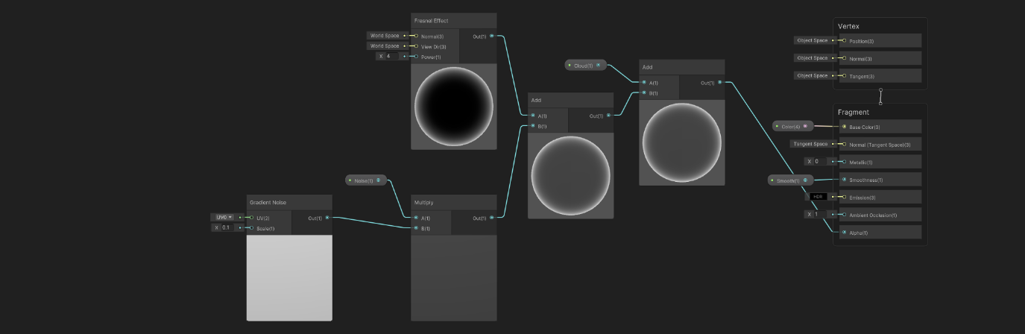effectively.

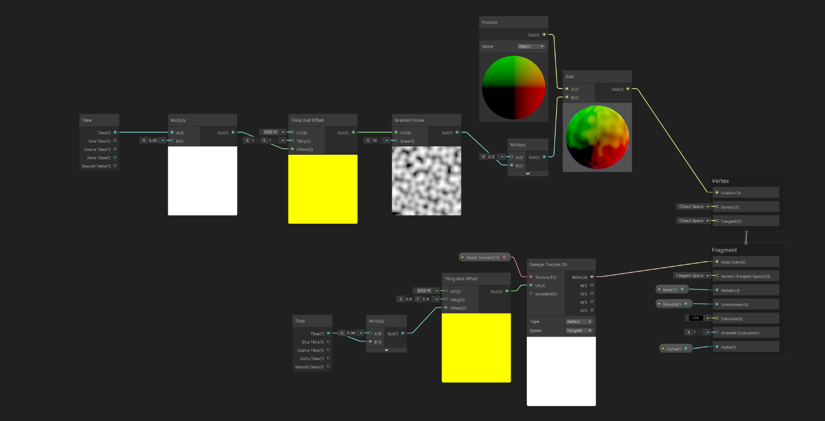The second is for the lake water in the environment. This one is slightly more complicated, but still quite simple. Most of the heavy lifting is done by this tileable texture I made in photoshop which the shader scrolls along the water object.

You can see in the images that I use few properties for each shader and this is just because time was very limited. For any other project, I would’ve made more properties so team members could easily tweak any materials using the shader.

The UI is probably what I struggled with the most. It didn’t help that I made it very late in the project and was starting to run short on time. I made it all in Photoshop and I’m proud that it’s all my own work, I didn’t get any external visual assets (except a font).

The final parts of the visual design were some post processing effects to help capture the mood and tone of the polluted landscape and a confetti particle effect for when the player successfully removes a piece of trash.

Sound

Sound effects and ambience were pivotal in order to capture the feeling I was going for with this game. I sourced free sound effects from freesound.org but then I combined and edited them in Audacity to get exactly what I wanted. Sound is one of the aspects of game development that I rarely participate in, so I’m very proud of how it turned out.

Post mortem

After release many people said they loved it, that it was cute, peaceful, creative, relaxing. The environment art and the claw light was specifically praised by a few people.

There were a few reviews that said they felt the game was too slow and that the claw should move faster.

Ominous and serene feeling (which I know is oxymoronic but it’s the best way to describe it) but with the comfort and reassurance that everything will be okay in the end. Sort of the peaceful, melancholy feeling of sheltering cozy inside your home while a thunderstorm rages outside.

The game jam had one winner for each category: overall, theme, and people’s choice. The games that won were well deserved and I’m very happy for each of them. Since I wasn’t in a team and only used a quarter of the time I could’ve, I didn’t expect to place very well when ranked along with all the other games but I was pleasantly surprised to see I placed 21st out of 50 for people’s choice.

Design (sorta) problem I ran into that didn’t have an easy fix – I wanted the world to feel overwhelmed with trash but also wanted the player to clean it all up but the player can only do it one piece at a time but the game should only take 5 minutes or less. These don’t all fit together in this iteration so it only made sense to get rid of the first one (or at least tone is way down)

What I would change / fix / add to if I had more time:

* Claw sometimes grabbing the ground bug. Not great but fixes itself so it doesn’t soft lock the player.
* Water splash particle fx kinda suck. Oh well
* Main menu could use a decorative sprite in the lower left. That’s what the space is visually balanced for.

You can download the game and play it for yourself here.

## Stil need

Clean up and add post mortem

Add a bunch more pictures so anyone reading can actually see the game without having to play it (coz people employing probs wont bother)

Add italics back in to html

Formatting on the website kinda feels weird

# New

Header picture and tagline

List of tools used, my roles, main focus points

Context. Game jam. Theme. By myself, used less time. Maybe also use a sentence to show appreciation for team work.

Brief overview of the game. PX goals (lmao)

Brief overview of design. Mainly talk about how the design eveloved from authentic claw game. To avoiding frustrating design aspects.

programming, art. Show lots of gifs and pictures.

Post mortem. What people thought. What I would change.

Download here!

Embed gameplay video ~somewhere~

Include date / year

Name, contact info, game designer / programmer on top of EVERY page

**

*Help restore a poor polluted micro-biome stuck in an arcade claw machine to its former wonder*

*Untrashed* is a game I made for the Ubisoft Australia Game Jam 2024. I made it by myself in just a few days over a break in the uni semester.

Tools

* Unity
  + C#
  + Probuilder
  + Shader graphs
* Audacity
* Photoshop
* Magicavoxel

My roles

* Design
* Programming
* 2D, 3D, shader art
* Sound

Focus points

* Unique mechanic
* Polish
* Responsive feedback systems
* Capture my intended player experience as described below

*Untrashed* featured a little biome in a claw machine where the player has to use the claw to grab pieces of trash out of the environment. I wanted it to evoke an ominous but serene feeling in the player, with the comfort and reassurance that everything will be okay in the end. Sort of the peaceful, melancholy feeling of sheltering cozy inside your home while a thunderstorm rages outside.

I quickly got the claw moving and grabbing using Unity’s physics system with a spring joint and colliders, although I needed to edit lots of values to get it feeling right. While doing this I also whiteboxed the world and claw using Probuilder.

By the end of the first day, I got it to the point where it felt like a real claw game. But it soon became clear that this felt more frustrating than calming. My initial goal was to replicate a claw machine in a fun scenario but real claw machines aren’t really fun, or at least not fun in the way a player can actually gain skill and progress with them. Real claw games are designed to get money off of people and then give them the anticipation of *almost* winning something while seldom actually giving away a prize. From then on, each time I felt across this disconnect, I went in favour or what felt fair and fun. I gave my claw more bounce, swing and “weight” while also making it quickly settle in its position so players didn’t need to wait for it. The claw won’t drop things on its way to the prize chute. If the player misses and doesn’t pick up anything, the claw will speed up to give control back to the player quicker. I added camera angles so the player could look directly front and side on to see if they were aligned properly but I made it even easier to see this by adding a spotlight that points directly down from the claw. Every design choice I made was to minimise the frustration and annoyance that can be found in real claw machines.

I’d been doing a lot of programming recently for my university classes and I wanted to take a step back from that where I could for this project. So, I steered my design away from anything that would require me to code complex systems and just use Unity’s existing functionality wherever I could.

I rarely got to do art and sound for games so I was excited to jump into these aspects. I used a new program called MagicaVoxel for the 3D voxel environment and Photoshop (which I have years of experience in) for all the 2D pixel sprite art. I was quickly able to make some shaders using Unity’s shader graphs for the water and the glass surrounding the world. I also added some post-processing effects to help capture the mode and tone of the polluted landscape and a confetti particle effect for when the player successfully removes a piece of trash.

Sound effects and ambience were pivotal in order to capture the feeling I was going for with this game. I sourced free sound effects from freesound.org but then I combined and edited them in Audacity to get exactly what I wanted.

After release people many people said they loved it, that it was cute, peaceful, creative, and relaxing. The 3D environment art and claw light was specifically praised by several people.

There were a few reviews from people that said they felt the game was too slow and that the claw should move faster. I’m unsure if these players just weren’t the right people to enjoy this experience or if their suggestions truly would make the game more enjoyable for more people but I hesitate to increase the speed of the game since it would clash directly with the intended player experience. I wish I could’ve done more active playtesting to find what could be done to address this.

Given more time, there were only a few small things I would’ve changed. The claw occasionally get stuck in the ground (but quickly fixes itself so it doesn’t heavily impact the game), The water splash particle effect moves awkwardly with the bottles and the main menu is visually balanced for another sprite in the lower left that I didn’t get a chance to make.

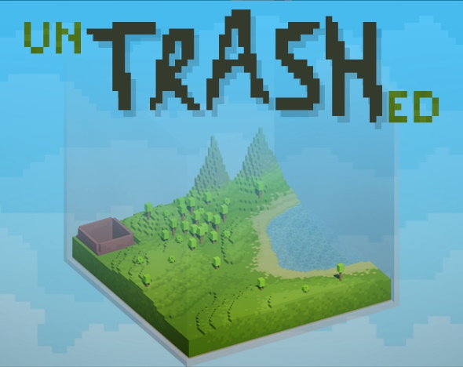All in all, I think I successfully achieved all the points I wanted to focus on with this project. I utilised a unique mechanic. I scoped well, so there was plenty of time for me to focus on polish and feedback systems. And players responses have aligned significantly with the intended player experience so I’m quite proud of myself.

You can download the game and play it for yourself here.